**Understanding support vector machines**

A **support vector machine** (**SVM**) can be imagined as a surface that creates a

boundary between points of data plotted in a multidimensional space representing

examples and their feature values.

The goal of an SVM is to create a flat boundary called a **hyperplane**, which divides the space to create fairly homogeneous partitions on either side.

Combination of kNN and Liner Regression, too powerful

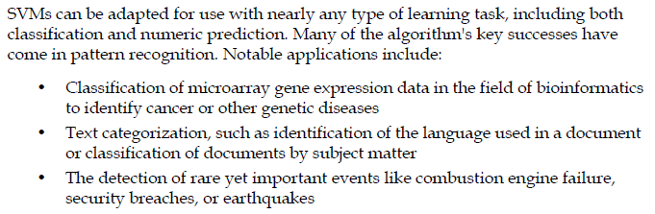

**Classification with hyperplanes**

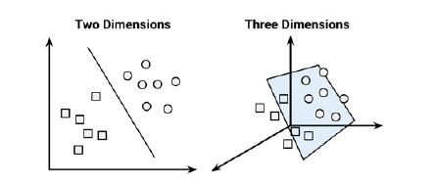

In two dimensions, the task of the SVM algorithm is to identify a line that separates

the two classes

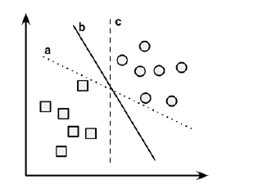

Search for the **maximum margin hyperplane** (**MMH**) that creates the greatest separation between the two classes.

The **support vectors** (indicated by arrows in the figure that follows) are the points from each class that are the closest to the MMH

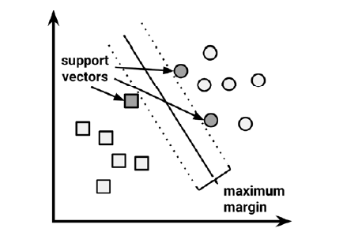

**The case of linearly separable data**

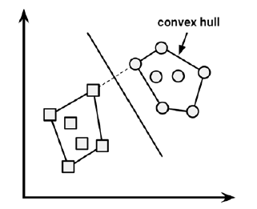

the MMH is as far away as possible from the outer boundaries of the two groups of data points. These outer boundaries are known as the **convex hull**. The MMH is then the perpendicular bisector of the shortest line between the two convex hulls. Sophisticated computer algorithms that use a technique known as **quadratic optimization** are capable of finding the maximum margin in this way.

In *n*-dimensional space, the following equation is used for a hyperplane:



W: weights, b: bias

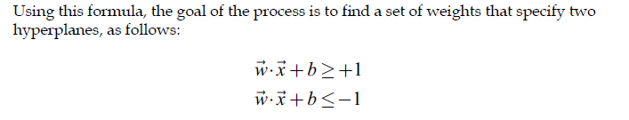

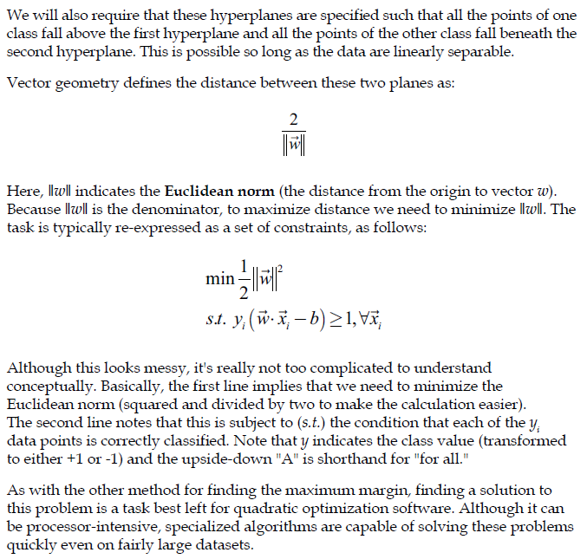

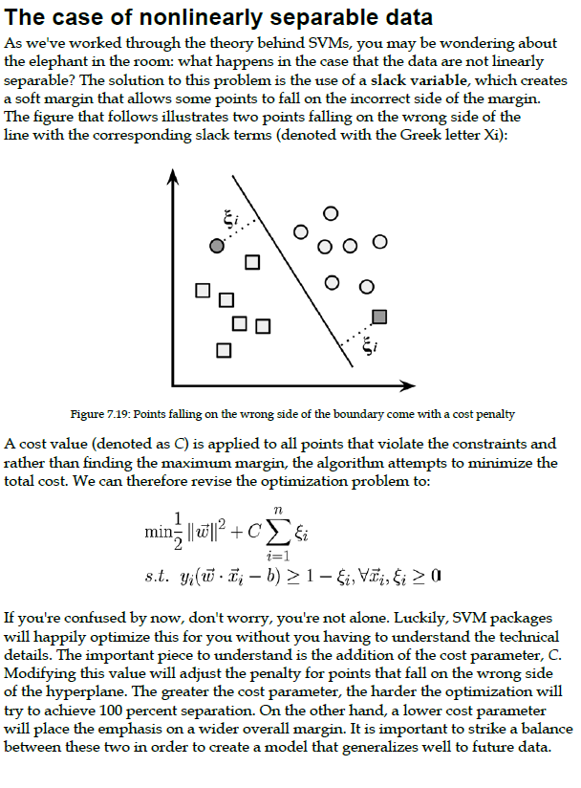

**Using kernels for nonlinear spaces**

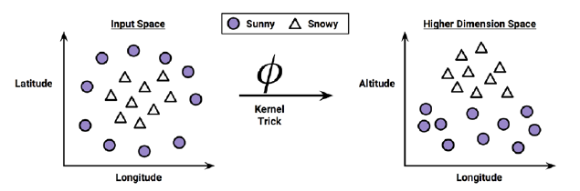

Altitude feature can be expressed mathematically as an interaction between Latitude and Longitude—the closer the point is to the centre of each of these scales, the greater the Altitude. This allows the SVM to learn concepts that were not explicitly measured in the original data.

